# EXERCISE 3

# Name: Velazquez, Adrian

# Date: 2020-09-13

A professor has recently taught two sections of the same course with only one difference between the sections. In one section, he used only examples taken from sports applications, and in the other section, he used examples taken from a variety of application areas. The sports themed section was advertised as such; so students knew which type of section they were enrolling in. The professor has asked you to compare student performance in the two sections using course grades and total points earned in the course. You will need to import the [Scores.csv](http://content.bellevue.edu/cst/dsc/520/id/resources/scores.csv) dataset that has been provided for you.

Use the appropriate R functions to answer the following questions:

1. What are the observational units in this study?

The observational units in this study are the students who took the course.

1. Identify the variables mentioned in the narrative paragraph and determine which are categorical and quantitative?

Categorical variable: Section- binary (sports or regular)

Quantitative: course grade and total points earned in the course

1. Create one variable to hold a subset of your data set that contains only the Regular Section and one variable for the Sports Section.
   1. setRegular <- subset(scores,scores$Section=="Regular")
   2. setSports <- subset(scores,scores$Section=="Sports")

4. Use the Plot function to plot each Sections scores and the number of students achieving that score. Use additional Plot Arguments to label the graph and give each axis an appropriate label. Once you have produced your Plots answer the following questions:

CODE:

scores <- read.csv("C:/GitHub/dsc520/data/scores.csv",stringsAsFactors = TRUE)

scores

colnames(scores)

head(scores)

data<-summary(scores)

data

setSports <- subset(scores,scores$Section=="Sports")

setSports

setRegular <- subset(scores,scores$Section=="Regular")

setRegular

summary(setSports)

summary(setRegular)

sum(setRegular$Count)

sum(setSports$Count)

par(mar=c(5.1, 4.1, 4.1, 8.1), xpd=TRUE)

plot(setSports$Count,setSports$Score, ylab = "Score", xlab = "Count", col="Red")

points(setRegular$Count,setRegular$Score, col= "Blue")

legend("topright", inset = c(-0.4,0),c("Sports","Regular"), bty = "n" , fill = c("Red","Blue"))

boxplot(scores$Score~scores$Section, ylab = "Score", xlab = "Section", col= c("Blue","Red"))

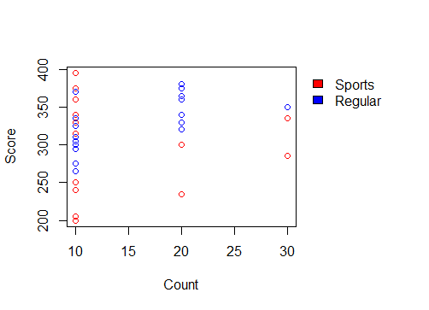 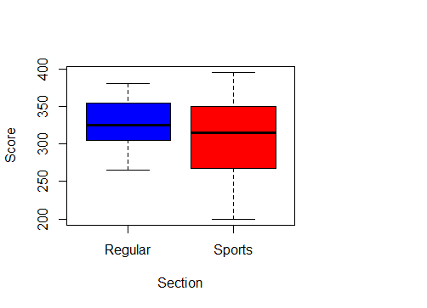

1. Comparing and contrasting the point distributions between the two section, looking at both tendency and consistency: Can you say that one section tended to score more points than the other? Justify and explain your answer.

Based on the observation from the summary() of both subsets we can tell that in the Regular section there is a tendency to get a higher score based on comparison of the median and the mean. But we have to take note that there were more students in the Regular section and that mode of the scores was scoring 320 in the Regular Section with 40 students getting that score.

mean(setRegular$Score) > mean(setSports$Score)

median(setRegular$Score) > median(setSports$Score)

1. Did every student in one section score more points than every student in the other section? If not, explain what a statistical tendency means in this context.

No, but some students from the Sports section got the higher scores at some point. But on the other hand, we can also observe that most of the scores from the Sports section were below the mean of the Regular section. The scores where distributed fairly. In this context we can see that there is a statistical tendency from the mean and median of the 2 sections subsets towards the mean and medium of the whole set that contains all the scores.

c. What could be one additional variable that was not mentioned in the narrative that could be influencing the point distributions between the two sections?

Another variable could be the time of day the class was taken, or the method of implementation(distance learning or in person learning), as well as the amount of students in the classroom.